**ASSISTED PRACTICE (RESPONSE ASSERTION)**

Step1: Right click on Junit request(in junit sampler) -> Add -> Assertions -> Response Assertion

Step2: In “Field to Test” Section -> Select the checkbox “Response code”

Step3: Click on Add at the bottom -> Double click on “Patterns to Test” section -> Enter Expected value in this section(Failure code – 0001) -> Save it

Step4: Right Click on Thread Group -> Add -> Listener -> Assertion results

Step5: Now, Execute this code to see the output :

In “View Results Tree” :

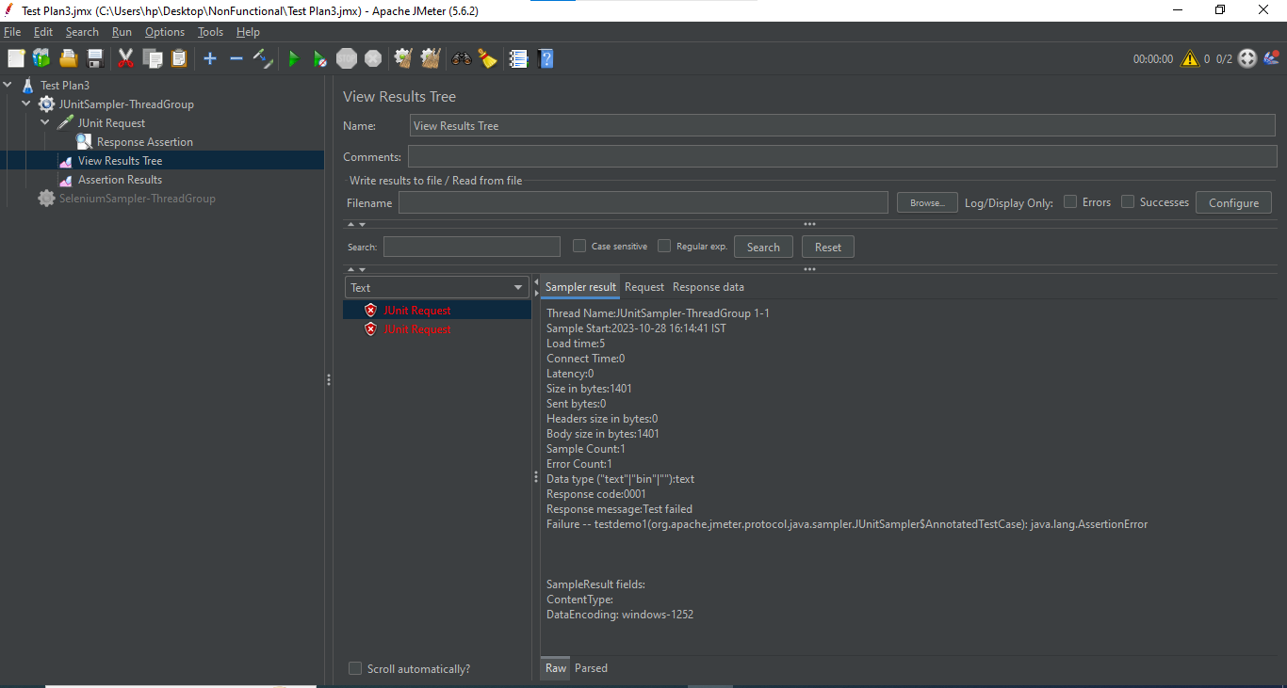

In Assertion Results:

